Snowflake Interview Questions and Answers – Architecture, Performance, ETL/ELT, Caching & Production Scenarios
Below are detailed, interview-oriented answers to all 23 Snowflake questions, with practical examples, technical explanations, troubleshooting approaches, and real-world production scenarios.
I have structured the answers to help you understand the concepts and explain them confidently in a Snowflake Data Engineer or Snowflake DBA interview.
1. Snowflake Architecture & Micro-partitions
Understanding Snowflake micro-partitions
lam-tran.dev

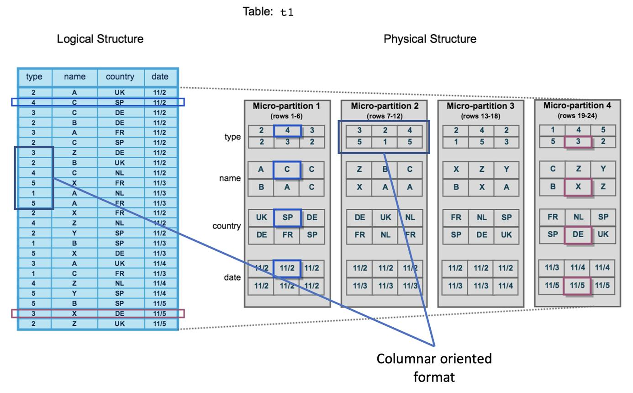
Q1. If a Snowflake table contains 500 columns, will all 500 columns be logically stored within the same micro-partition?
Answer:
Yes. Snowflake stores table data in micro-partitions, and each micro-partition contains data for all columns of the table for the rows assigned to that micro-partition.
However, Snowflake uses a columnar storage format internally.
For example, consider a table:
CREATE TABLE CUSTOMER (
CUSTOMER_ID NUMBER,
CUSTOMER_NAME VARCHAR,
EMAIL VARCHAR,
PHONE VARCHAR,
ADDRESS VARCHAR,
...
-- 500 columns
);
Snowflake organizes the data into micro-partitions, typically around 50–500 MB of uncompressed data.
Each micro-partition contains:
- Data for the rows belonging to that partition.
- Columnar data storage for the table's columns.
- Metadata such as minimum and maximum values.
- Distinct-value and other statistical information used for pruning.
Important interview point:
All 500 columns logically belong to the same micro-partition for its rows, but their values are stored in a column-oriented structure rather than as 500-column row records.
Q2. How does Snowflake organize data inside micro-partitions?
Answer:
Snowflake automatically divides table data into small, immutable storage units called micro-partitions.
Important characteristics:
- Each micro-partition generally contains 50–500 MB of uncompressed data.
- Data is stored in a columnar format.
- Each micro-partition contains approximately 50,000–500,000 rows, depending on row width and data characteristics.
- Snowflake maintains metadata for each micro-partition.
- Micro-partitions are immutable. When data changes, Snowflake creates new micro-partitions rather than modifying existing ones in place.
Example:
Suppose we load 10 million customer records into Snowflake.
Snowflake automatically divides the records into multiple micro-partitions.
Snowflake Cluster Keys: How to Improve Query Performance with Partitio
articles.analytics.today
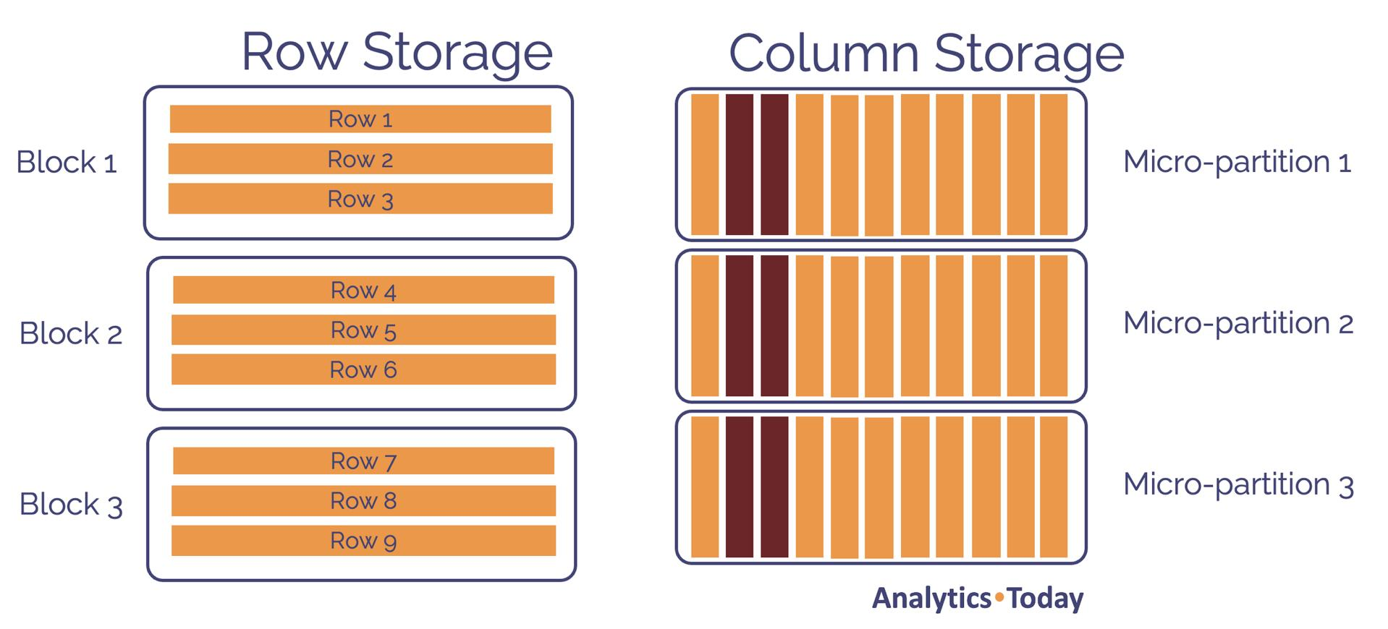
For example:
Micro-partition | Customer IDs
MP1 | 1–100,000
MP2 | 100,001–200,000
MP3 | 200,001–300,000
MP4 | 300,001–400,000
These are illustrative ranges, not guaranteed Snowflake partition boundaries.
Snowflake maintains metadata that helps identify which micro-partitions contain relevant data.
Real-world benefit: Snowflake can skip unnecessary micro-partitions instead of scanning the entire table.
Q3. If a query accesses only 2 columns from a table containing 500 columns, does Snowflake scan all 500 columns?
Answer: No, generally only the required columns are scanned.
Snowflake uses column pruning to read only the columns required by the query.
Example:
SELECT CUSTOMER_ID, CUSTOMER_NAME
FROM CUSTOMER
WHERE CUSTOMER_ID = 1001;
The table contains 500 columns, but this query requires only:
- CUSTOMER_ID
- CUSTOMER_NAME
Snowflake generally reads these required columns rather than reading all 500 columns.
It may also access additional columns required by expressions, filters, joins, grouping, sorting, and other operations.
Interview point: Column pruning reduces the amount of data read from storage, improving query performance and reducing unnecessary I/O.
Q4. How do column pruning and micro-partition pruning work?
Answer:
These are two different Snowflake optimization techniques.
1. Column pruning
Column pruning eliminates unnecessary columns from the scan.
Example:
SELECT EMPLOYEE_ID, SALARY
FROM EMPLOYEE;
If the table contains 100 columns, Snowflake only needs the two requested columns for this query.
2. Micro-partition pruning
Micro-partition pruning eliminates unnecessary micro-partitions based on metadata.
Example:
SELECT *
FROM SALES
WHERE ORDER_DATE = '2026-01-15';
Suppose the table has 100 micro-partitions.
Snowflake checks the metadata for each micro-partition, including minimum and maximum ORDER_DATE values.
If a micro-partition contains dates only between January 1 and January 5, it can be skipped.
Only micro-partitions that may contain January 15 data need to be scanned.
The Anatomy of Performance: Inside Snowflake’s Three-Layer Engine | by Ismail Mezzour | Feb, 2026 | Medium
medium.com
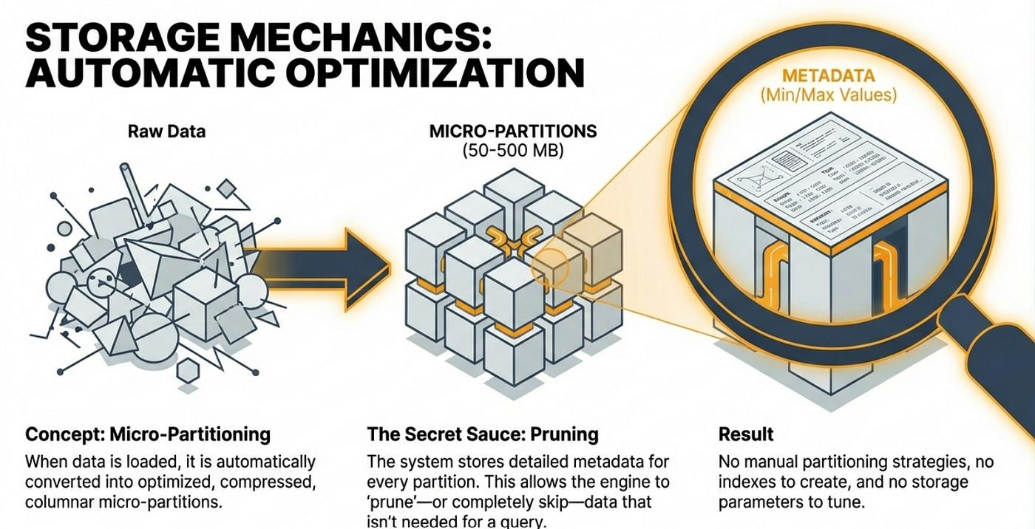
Difference:
Feature | Column pruning | Micro-partition pruning
What is eliminated? | Unnecessary columns | Unnecessary micro-partitions
Based on | Query column requirements | Micro-partition metadata
Main benefit | Less column data scanned | Fewer storage partitions scanned
Example | Selecting 2 of 500 columns | Filtering one date range
Interview tip: Both techniques can work together in the same query.
2. Snowflake Tasks & Virtual Warehouse
Snowflake Deep Dive: Architecture, Performance, and How It Compares to BigQuery & Redshift
daisuke.masuda.tokyo
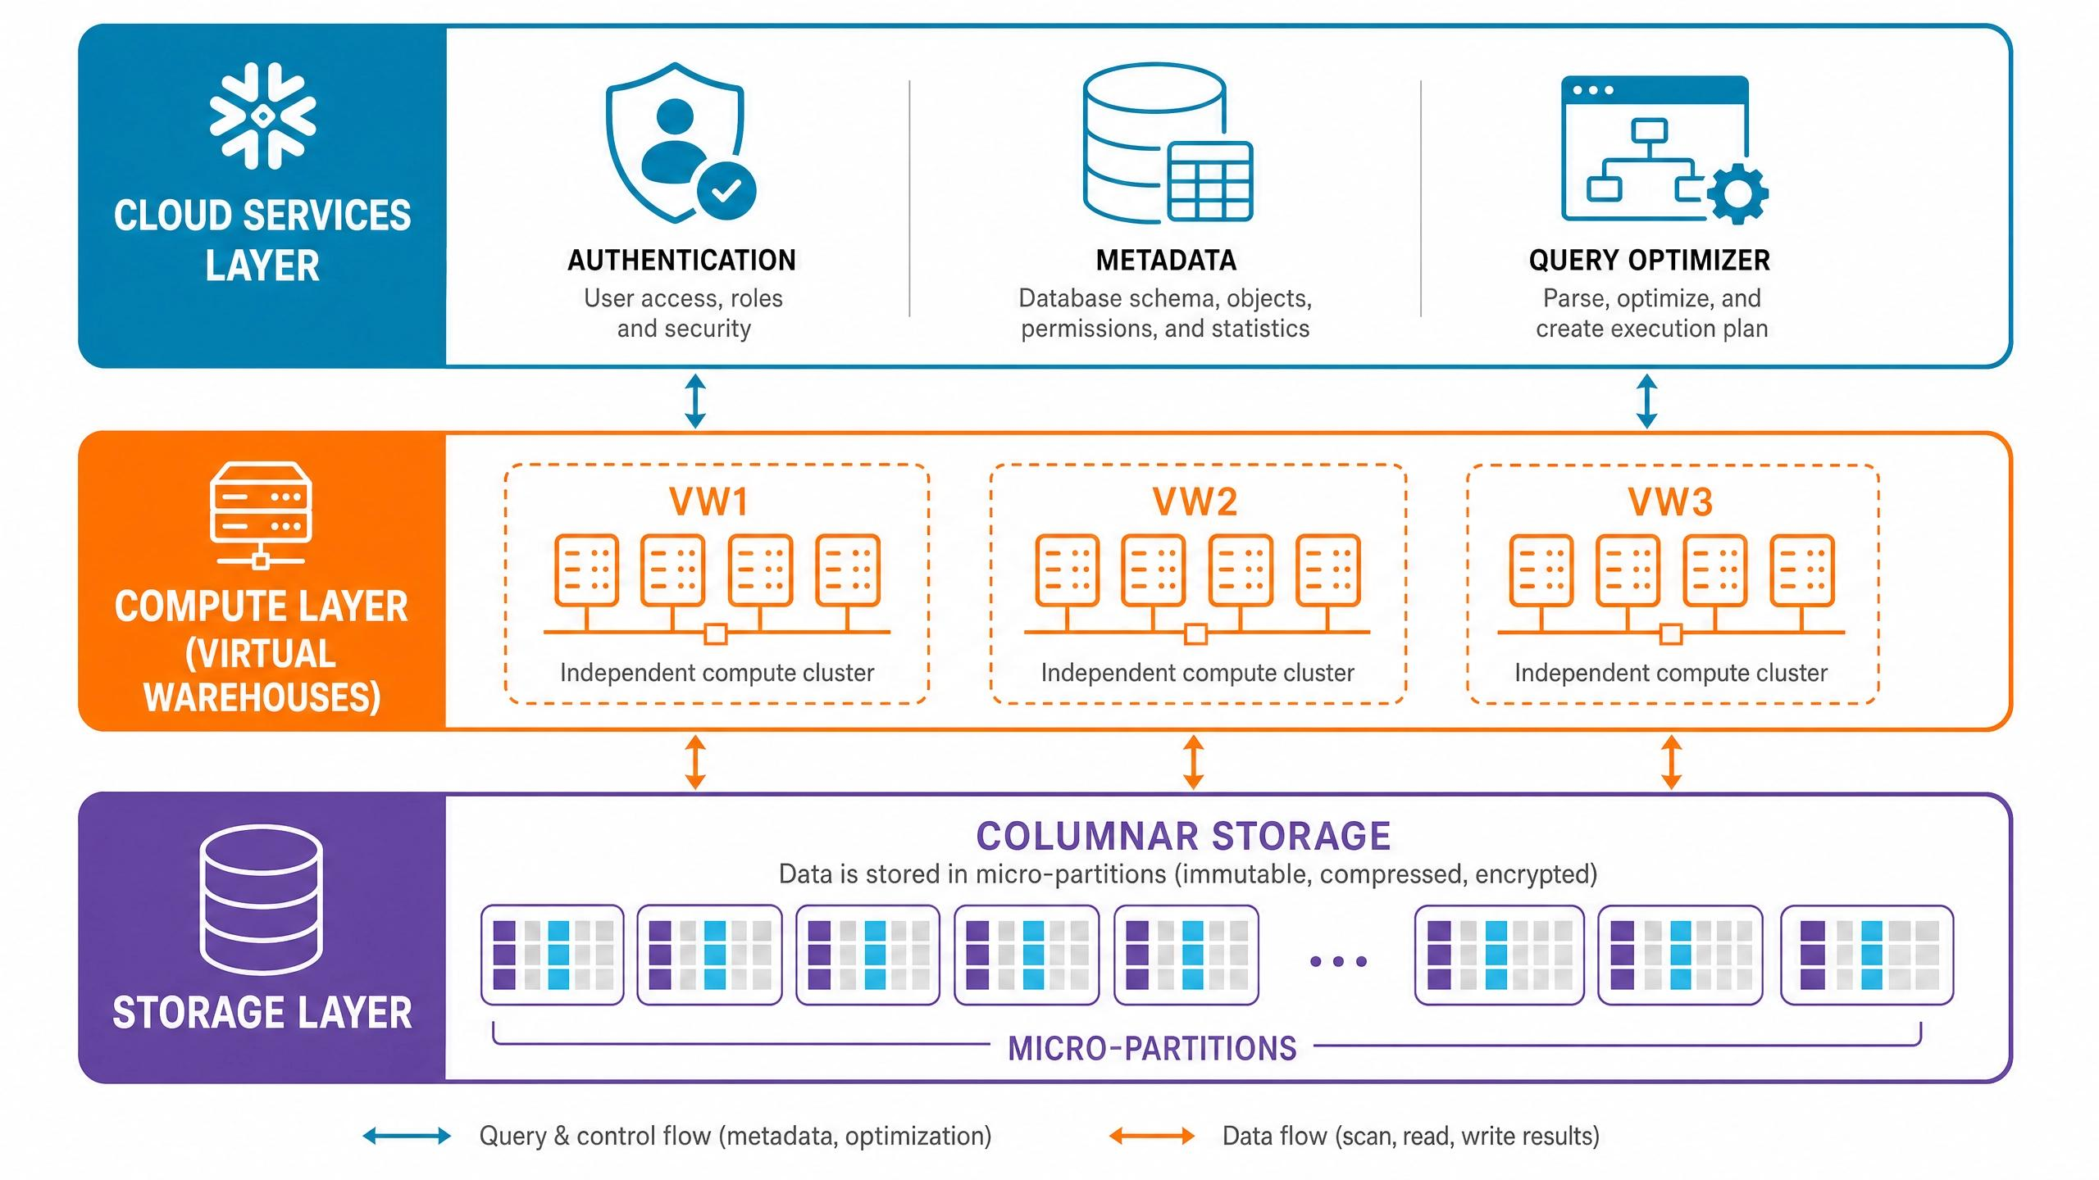
Q5. While creating a Snowflake Task, how do you decide the appropriate virtual warehouse size?
Answer:
I would select the virtual warehouse size based on the workload requirements, data volume, query complexity, execution time, concurrency, and SLA.
A Snowflake Task can execute SQL statements or call stored procedures based on a schedule or dependency.
Example:
CREATE OR REPLACE TASK DAILY_SALES_TASK
WAREHOUSE = ETL_WH
SCHEDULE = 'USING CRON 0 2 * * * UTC'
AS
INSERT INTO DAILY_SALES_SUMMARY
SELECT
ORDER_DATE,
SUM(SALES_AMOUNT)
FROM SALES
GROUP BY ORDER_DATE;
When choosing the warehouse size, I consider:
- Data volume: How much data needs to be processed?
- Query complexity: Does the task involve joins, aggregations, window functions, or large transformations?
- Execution time: How long does the task currently take?
- SLA: Does the job need to finish within 10 minutes, 30 minutes, or 2 hours?
- Concurrency: Are multiple tasks running simultaneously?
- Cost: How many credits will the warehouse consume?
I would initially test with a smaller warehouse, monitor performance, and scale up if the workload cannot meet its SLA efficiently.
Q6. What factors should be considered when selecting a warehouse size?
Answer:
The main factors are:
Factor | Explanation
Data volume | Amount of data processed
Query complexity | Joins, aggregations, sorting, transformations
Concurrency | Number of simultaneous queries
Execution time | Required processing time
SLA | Business deadline
Memory requirements | Whether queries spill to local or remote storage
Cost | Credit consumption
Workload type | ETL, reporting, BI, ad hoc queries
Snowflake warehouse sizes generally follow this progression:
Warehouse size | Relative compute capacity
X-Small | 1x
Small | 2x
Medium | 4x
Large | 8x
X-Large | 16x
2X-Large | 32x
3X-Large | 64x
4X-Large | 128x
These are relative capacity multipliers, not guaranteed query speed improvements.
For example, if an ETL job takes 60 minutes on an X-Small warehouse, a larger warehouse might reduce execution time. However, the actual improvement depends on whether the query can use additional compute effectively.
Q7. How do data volume, query complexity, execution time and SLA influence warehouse sizing?
Answer:
Let's consider a real-world example.
Suppose a company processes 500 GB of sales data every night.
The business requires the ETL pipeline to finish within 30 minutes.
Scenario 1: Small data volume
- Data volume: 5 GB
- Query complexity: Simple INSERT
- SLA: 2 hours
An X-Small or Small warehouse may be sufficient.
Scenario 2: Medium data volume
- Data volume: 100 GB
- Query complexity: Multiple joins and aggregations
- SLA: 30 minutes
A Medium or Large warehouse may be appropriate after testing.
Scenario 3: Large data volume
- Data volume: 2 TB
- Query complexity: Complex transformations and large joins
- SLA: 15 minutes
A Large or X-Large warehouse may be required, depending on query characteristics.
My approach in production:
- Start with a smaller warehouse.
- Execute representative workloads.
- Check Query Profile.
- Identify execution bottlenecks.
- Check spilling and queueing.
- Increase warehouse size if additional compute can solve the bottleneck.
- Compare execution time against credit consumption.
The goal is not simply to select the biggest warehouse. The goal is to meet the SLA at an acceptable cost.
Q8. In which scenario would you scale up a warehouse versus use a multi-cluster warehouse?
Important interview question
Answer:
Snowflake provides two approaches to scaling compute:
1. Scale up (Vertical scaling)
Scaling up means increasing the size of a virtual warehouse.
Example:
X-Small → Small → Medium → Large
Use scaling up when:
- A complex query takes too long.
- Large joins require more compute resources.
- Queries spill to storage because of memory pressure.
- A large ETL transformation needs to finish faster.
- Individual queries need additional processing power.
2. Multi-cluster warehouse (Horizontal scaling)
A multi-cluster warehouse adds clusters to handle concurrent workloads.
Use it when:
- Many BI users execute queries simultaneously.
- Multiple users are experiencing queueing.
- Concurrent reporting workloads create resource contention.
- You want to improve concurrency without necessarily increasing the size of each cluster.
Example:
Suppose 100 business users access Power BI dashboards simultaneously.
A single Medium warehouse may experience query queueing.
Instead of increasing the warehouse to X-Large, we can configure a multi-cluster warehouse with Medium-sized clusters.
This allows additional clusters to handle concurrent queries.
Scenario | Recommended approach
One query is running slowly | Scale up
Complex ETL transformation | Scale up
Many queries are queued | Multi-cluster
High BI concurrency | Multi-cluster
Both complex queries and high concurrency | Consider both
Important: Multi-cluster warehouses primarily address concurrency. They do not automatically make one individual query execute faster.
3. ETL vs ELT
What is a Data Pipeline? Your Complete Beginner’s Guide (2025) | by Timothy Kimutai | Medium
timkimutai.medium.com
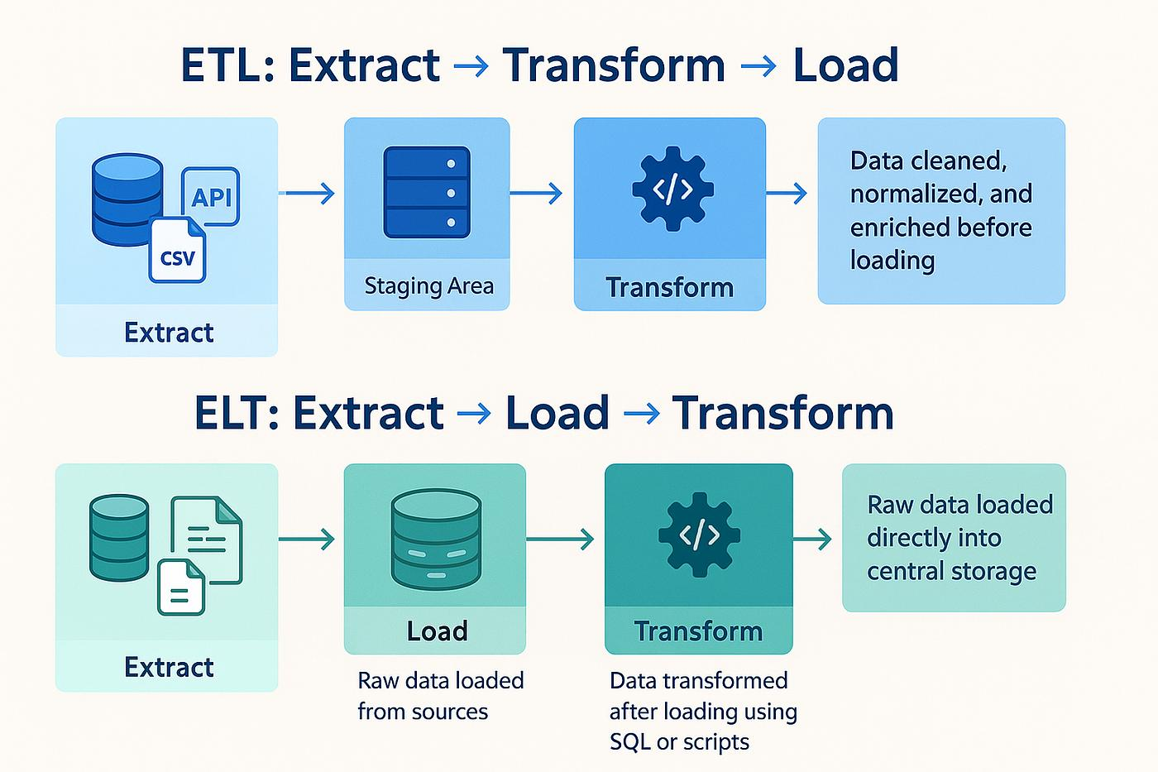
Q9. In which scenarios would you choose ETL over ELT?
Answer:
ETL stands for Extract, Transform, Load.
In ETL, data is transformed before loading into the target data warehouse.
I would choose ETL in the following scenarios:
1. Sensitive data protection
If source data contains confidential information, such as customer names, credit card numbers, or personal information, sensitive fields may need to be masked or tokenized before loading.
2. Regulatory requirements
Certain organizations require sensitive information to be removed or transformed before it reaches the analytical environment.
3. Complex preprocessing
If data requires extensive cleansing, validation, or transformations that are better handled in an external processing platform, ETL may be suitable.
4. Source data standardization
If data comes from multiple source systems with different formats, it may need to be standardized before loading.
Example:
Source system:
Customer ID | Name | Credit Card
101 | John | 1234567890123456
Before loading into Snowflake, the ETL tool can tokenize or redact the credit card number.
Q10. Why is ELT generally preferred when working with Snowflake and dbt?
Answer:
ELT stands for Extract, Load, Transform.
In ELT, raw data is first loaded into Snowflake, and transformations happen inside Snowflake.
ELT is generally preferred because Snowflake provides scalable cloud computing resources, while dbt is designed to manage SQL-based transformations inside the data warehouse.
Architecture:
Snowflake for AWS-First Data Engineers (Part 7) — Designing a Snowflake-Centric Data Platform on AWS | by bingeek | Feb, 2026 | Medium
medium.com
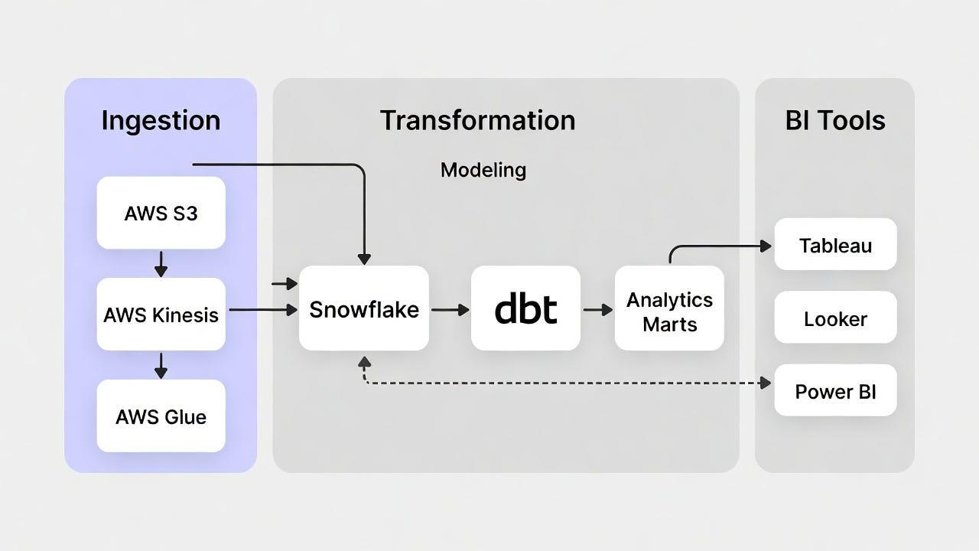
Example:
Step 1: Extract data from source systems.
Step 2: Load raw data into Snowflake.
CREATE TABLE RAW_CUSTOMERS (
CUSTOMER_ID NUMBER,
CUSTOMER_NAME VARCHAR,
EMAIL VARCHAR
);
Step 3: Transform using dbt.
SELECT
CUSTOMER_ID,
UPPER(CUSTOMER_NAME) AS CUSTOMER_NAME,
LOWER(EMAIL) AS EMAIL
FROM {{ source('raw', 'customers') }}
Step 4: Store transformed data in a curated table.
Advantages of ELT:
- Uses Snowflake's scalable compute resources.
- Keeps raw data available for future transformations.
- Simplifies transformation management.
- Supports reusable dbt models.
- Provides version control and testing.
- Separates ingestion from transformation.
- Reduces the need for a separate transformation engine.
Interview point: Snowflake handles the processing, while dbt manages transformation logic, dependencies, testing, and documentation.
Q11. If source data contains sensitive customer information, how would you handle masking before loading it into Snowflake?
Answer:
I would first identify sensitive fields and understand the organization's security and compliance requirements.
There are several approaches.
Approach 1: Mask before loading
If regulations or security policies require that sensitive information must never enter Snowflake in its original form, I would mask or tokenize the data in the source system or ingestion pipeline.
Example:
Original data:
Customer Name: John
Credit Card: 1234567890123456
Masked data:
Customer Name: John
Credit Card: XXXXXXXXXXXX3456
Only the masked data is loaded into Snowflake.
Approach 2: Snowflake Dynamic Data Masking
If the organization allows sensitive data to be stored in Snowflake but restricts who can view it, I would use masking policies.
Example:
CREATE OR REPLACE MASKING POLICY
CARD_MASK AS (VAL STRING)
RETURNS STRING ->
CASE
WHEN CURRENT_ROLE() IN ('SECURITY_ADMIN')
THEN VAL
ELSE 'XXXXXXXXXXXX' || RIGHT(VAL, 4)
END;
Apply the policy:
ALTER TABLE CUSTOMER
MODIFY COLUMN CREDIT_CARD
SET MASKING POLICY CARD_MASK;
Now authorized users can see the original value, while other roles see a masked value.
Approach 3: Tokenization
For highly sensitive fields, I would consider tokenization so the original value is replaced with a token.
Important interview distinction:
Dynamic masking controls what users see when querying Snowflake. It does not remove or encrypt the original value before loading.
If the requirement is to prevent sensitive data from entering Snowflake, masking or tokenization must happen upstream.
4. Snowflake Caching
Top 3 Snowflake Performance Tuning Tactics
dzone.com
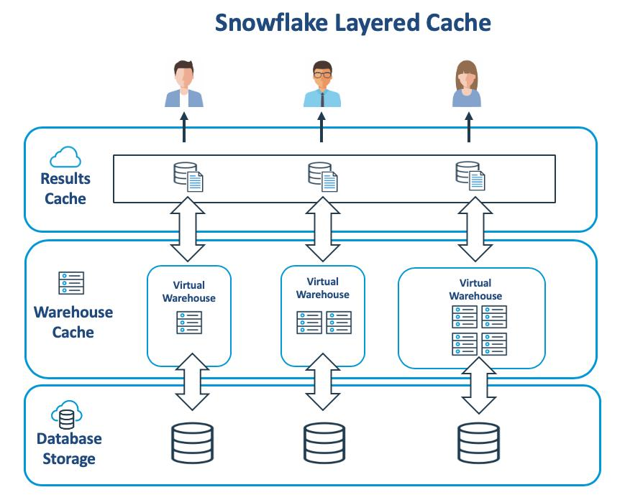
Q12. What are the different caching mechanisms available in Snowflake?
Answer:
Snowflake uses different caching and metadata optimization mechanisms to improve query performance and reduce compute consumption.
The three commonly discussed mechanisms are:
- Result Cache (Persisted Query Results)
- Warehouse Cache (Local Disk Cache)
- Metadata Cache / Metadata Optimization
1. Result Cache
Snowflake stores the results of previously executed queries.
If the same query is executed again and the result is eligible for reuse, Snowflake can return the previous result without executing the query again.
Example:
SELECT COUNT(*)
FROM CUSTOMER;
Suppose the first execution takes 10 seconds.
If the same query is executed again and the underlying data and other reuse conditions remain valid, Snowflake can return the cached result much faster.
Advantages:
- Reduces query execution time.
- Avoids unnecessary compute processing.
- Reduces warehouse credit consumption for eligible reused results.
2. Warehouse Cache
Warehouse Cache stores previously accessed table data in the local cache of an active virtual warehouse.
Example:
SELECT *
FROM SALES
WHERE REGION = 'INDIA';
The first query reads data from Snowflake storage.
If subsequent queries access the same data, Snowflake may retrieve it from the warehouse cache rather than reading it again from remote storage.
Advantages:
- Reduces storage I/O.
- Improves repeated query performance.
- Reduces data retrieval latency.
3. Metadata Cache
Snowflake maintains metadata about tables, micro-partitions, columns, and other database objects.
Examples of metadata include:
- Number of rows.
- Micro-partition information.
- Minimum and maximum column values.
- Table statistics.
- Object definitions.
Snowflake uses this information to optimize queries and, in some cases, answer queries without scanning table data.
For example:
SELECT COUNT(*)
FROM CUSTOMER;
Depending on the table and query conditions, Snowflake may use metadata rather than scanning every row.
Interview point: Metadata optimization is different from result caching and warehouse data caching. It is not simply another user-managed cache that you configure or clear.
Q13. What is the difference between Result Cache, Warehouse Cache and Metadata Cache?
Answer:
Feature | Result Cache | Warehouse Cache | Metadata Cache
Stores | Previous query results | Previously accessed table data | Table and micro-partition metadata
Location | Snowflake-managed persisted results | Warehouse local storage | Snowflake-managed metadata services
Purpose | Reuse query results | Avoid repeated remote data reads | Optimize query planning and data access
Requires query execution? | Usually no, if eligible | Yes, query still executes | Depends on query
Warehouse suspension | Persisted results remain subject to their retention rules | Cache is dropped | Metadata remains managed by Snowflake
Main benefit | Faster repeated queries | Faster data retrieval | Efficient query optimization
Example to remember:
- Result Cache: Reuse the answer.
- Warehouse Cache: Reuse previously accessed data.
- Metadata Cache: Use information about the data to optimize processing.
Q14. What happens to warehouse cache when a virtual warehouse is suspended?
Answer:
When a virtual warehouse is suspended, its local warehouse cache is dropped.
When the warehouse resumes, it starts with an empty local data cache.
Example:
- A BI user executes a report.
- Snowflake reads the required data and stores frequently accessed data in the warehouse cache.
- The same report executes again and may benefit from the cache.
- The warehouse is suspended after 10 minutes of inactivity.
- The warehouse resumes the following morning.
- Its local warehouse cache is empty.
- The first query may take longer because it needs to retrieve data again.
Types of Cache in Snowflake and How They Accelerate Your Queries | by Naman Taneja | Medium
medium.com
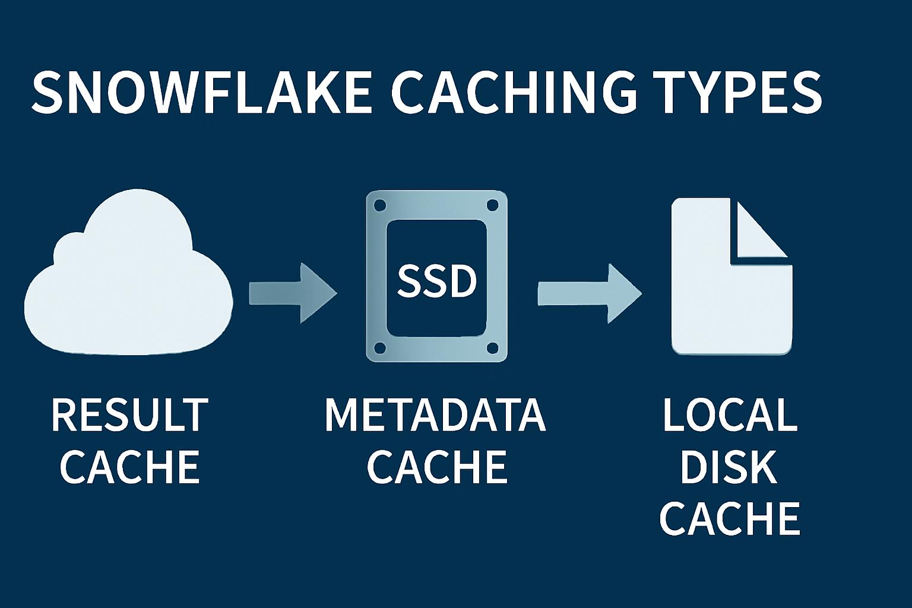
Important distinction:
Suspending a warehouse clears its local warehouse cache, but it does not automatically clear persisted query results.
Production recommendation:
For frequently used BI workloads, configure an appropriate AUTO_SUSPEND value based on usage patterns.
For example:
ALTER WAREHOUSE BI_WH
SET AUTO_SUSPEND = 300;
This suspends the warehouse after five minutes of inactivity.
The decision should balance:
- Credit savings.
- Query frequency.
- Cache reuse.
- Business SLA.
Snowflake's documentation explains that warehouse cache is dropped on suspension and rebuilt as queries execute after resumption.
Snowflake Documentation+2
Q15. How does caching improve query performance and reduce compute consumption?
Answer:
Caching improves performance by avoiding unnecessary repeated work.
Let's consider a real-world scenario.
A company has a sales dashboard that executes the following query every five minutes:
SELECT
REGION,
SUM(SALES_AMOUNT)
FROM SALES
GROUP BY REGION;
First execution:
- Snowflake reads the required data.
- Performs aggregation.
- Returns the result.
- May populate the warehouse cache.
Second execution:
If the exact query is eligible for persisted result reuse, Snowflake can return the previous result directly.
If result reuse is not possible, the query may still benefit from warehouse caching by reading previously accessed data from local cache.
Benefits:
- Faster query execution.
- Less repeated data retrieval.
- Lower compute consumption when persisted results are reused.
- Better dashboard response times.
- Improved overall workload efficiency.
Interview tip: Result cache can avoid warehouse query execution entirely for eligible queries. Warehouse cache still requires compute to execute the query.
5. Production Workload Management
The Anatomy of Performance: Inside Snowflake’s Three-Layer Engine | by Ismail Mezzour | Feb, 2026 | Medium
medium.com
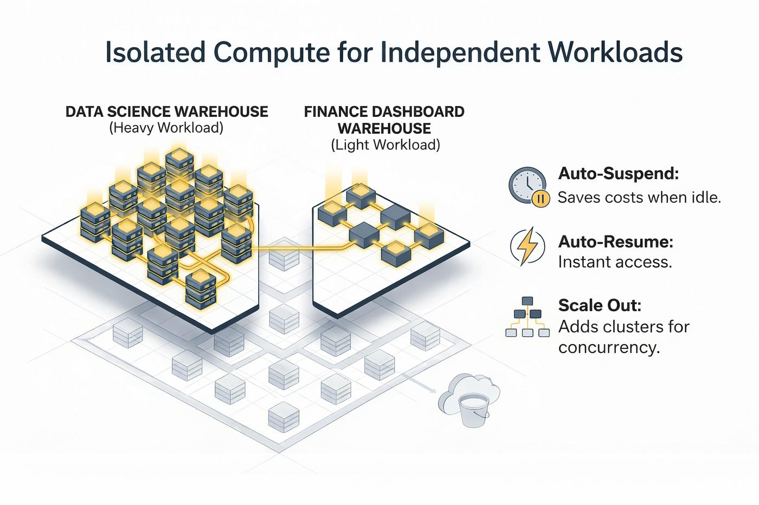
Q16. An ETL job and BI users are accessing the same Snowflake warehouse simultaneously, causing ETL execution to slow down. How would you handle this?
Answer:
I would first investigate whether the issue is caused by warehouse resource contention, query queueing, or inefficient SQL execution.
In production, sharing one warehouse between ETL and BI workloads can create resource contention.
For example:
- ETL jobs execute large joins and transformations.
- BI users execute multiple dashboard queries.
- Both workloads compete for the same warehouse resources.
- ETL queries may experience increased execution time or queueing.
My troubleshooting and resolution approach:
Step 1: Analyze Query History
I would check query execution history.
SELECT
QUERY_ID,
QUERY_TEXT,
WAREHOUSE_NAME,
EXECUTION_STATUS,
TOTAL_ELAPSED_TIME,
QUEUED_OVERLOAD_TIME,
BYTES_SCANNED
FROM SNOWFLAKE.ACCOUNT_USAGE.QUERY_HISTORY
WHERE START_TIME >= DATEADD(HOUR, -24, CURRENT_TIMESTAMP())
ORDER BY START_TIME DESC;
This helps identify:
- Long-running queries.
- Query queueing.
- Data scanned.
- Execution patterns.
- Failed queries.
Step 2: Check Warehouse Load
I would review warehouse load monitoring and identify whether queries are waiting for compute resources.
Step 3: Separate ETL and BI Workloads
I would create separate virtual warehouses.
CREATE WAREHOUSE ETL_WH
WAREHOUSE_SIZE = 'LARGE'
AUTO_SUSPEND = 300
AUTO_RESUME = TRUE;
CREATE WAREHOUSE BI_WH
WAREHOUSE_SIZE = 'MEDIUM'
AUTO_SUSPEND = 300
AUTO_RESUME = TRUE;
Step 4: Assign Workloads
- ETL pipelines use ETL_WH.
- Power BI or Tableau users use BI_WH.
- Ad hoc analytical queries can use a separate warehouse if necessary.
Step 5: Monitor Performance
I would compare:
- ETL execution time.
- BI query response time.
- Warehouse credit consumption.
- Queueing time.
- Resource utilization.
Expected result: Workload isolation reduces resource contention and allows ETL and BI workloads to operate independently.
Q17. How would you isolate ETL and BI workloads in Snowflake?
Answer:
I would use separate virtual warehouses for different workloads.
Example architecture:
Tuning Snowflake. Snowflake is provided as a Software as… | by John Ryan | Medium
medium.com
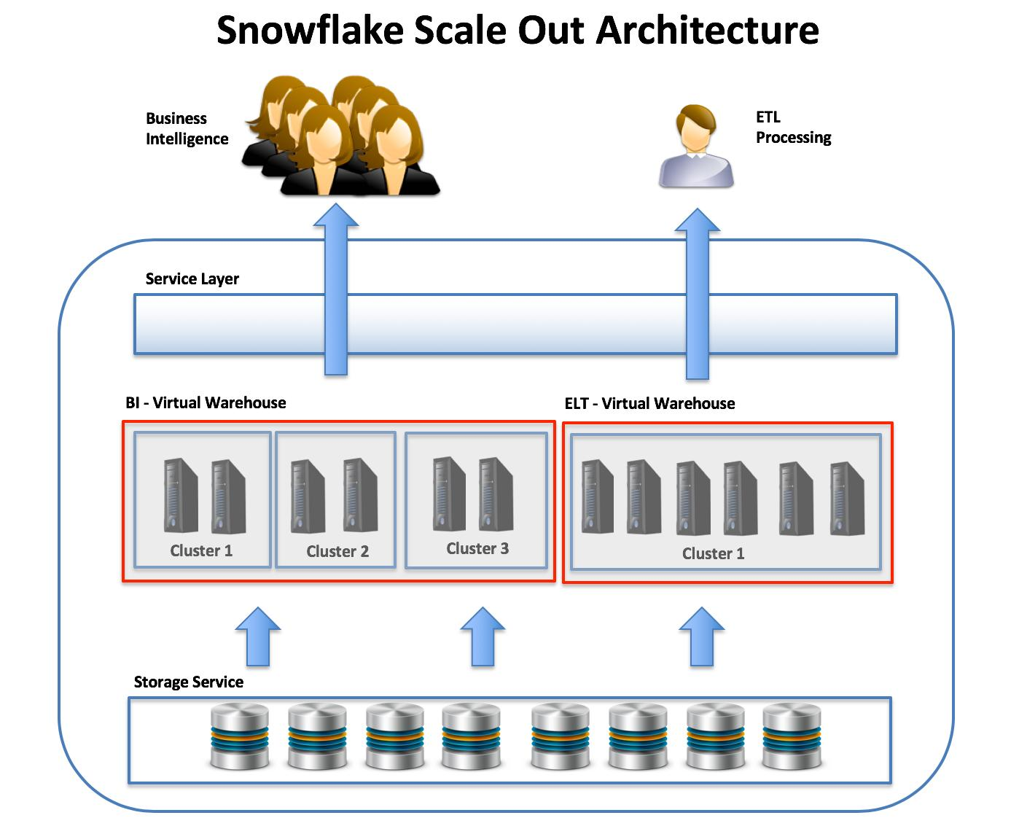
ETL Warehouse
Used for:
- Data ingestion.
- dbt transformations.
- Stored procedures.
- Batch processing.
- Data cleansing.
- Data aggregation.
BI Warehouse
Used for:
- Power BI.
- Tableau.
- Dashboard queries.
- Business reporting.
- Ad hoc analytical queries.
Example SQL:
CREATE WAREHOUSE ETL_WH
WAREHOUSE_SIZE = 'LARGE'
AUTO_SUSPEND = 300;
CREATE WAREHOUSE REPORTING_WH
WAREHOUSE_SIZE = 'MEDIUM'
AUTO_SUSPEND = 120;
I would also configure appropriate role permissions and warehouse access controls.
For example:
- ETL_ROLE gets access to ETL_WH.
- BI_ROLE gets access to REPORTING_WH.
This provides:
- Compute isolation.
- Independent scaling.
- Better workload monitoring.
- Improved performance.
- Easier cost allocation.
Important: Snowflake separates compute warehouses, but the underlying database storage remains shared.
Q18. When would you use separate virtual warehouses?
Answer:
I would use separate virtual warehouses when different workloads have different performance, concurrency, scheduling, or cost requirements.
Common scenarios:
Workload | Warehouse
Data ingestion | INGESTION_WH
dbt transformations | ETL_WH
Power BI reporting | BI_WH
Tableau dashboards | REPORTING_WH
Data science | DATA_SCIENCE_WH
Development and testing | DEV_WH
Ad hoc analysis | ANALYTICS_WH
Real-world example:
Suppose a company has the following workloads:
- ETL jobs run from 1 AM to 5 AM.
- BI dashboards are accessed throughout the day.
- Data scientists execute complex queries.
- Developers perform testing during business hours.
If all workloads use the same warehouse, resource contention can occur.
I would create separate warehouses based on workload requirements.
Advantages:
- Better resource isolation.
- Independent warehouse sizing.
- Separate auto-suspend settings.
- Independent credit monitoring.
- Better workload performance.
- Easier troubleshooting.
Q19. How would you manage concurrency without unnecessarily increasing warehouse costs?
Answer:
I would focus on improving concurrency management before simply increasing warehouse size.
My approach would include the following:
1. Use Multi-cluster Warehouses
If multiple users execute queries simultaneously, I would consider multi-cluster warehouses.
Example:
CREATE WAREHOUSE BI_WH
WAREHOUSE_SIZE = 'MEDIUM'
MIN_CLUSTER_COUNT = 1
MAX_CLUSTER_COUNT = 3
SCALING_POLICY = 'STANDARD'
AUTO_SUSPEND = 300;
This allows additional clusters to start when concurrency increases, subject to the configured scaling policy.
2. Separate Workloads
I would separate ETL, BI, and ad hoc queries into different warehouses.
3. Optimize SQL Queries
I would identify:
- Unnecessary SELECT * statements.
- Inefficient joins.
- Repeated calculations.
- Large table scans.
- Missing filter conditions.
- Expensive aggregations.
4. Use Appropriate Warehouse Sizes
I would avoid running small queries on unnecessarily large warehouses.
5. Configure Auto-suspend and Auto-resume
This helps reduce idle warehouse consumption.
6. Monitor Query Queueing
I would use warehouse load monitoring and query history to identify concurrency bottlenecks.
7. Use Query Acceleration Where Appropriate
For eligible workloads, Snowflake Query Acceleration Service can help accelerate portions of queries, particularly outlier queries.
Interview conclusion:
My objective would be to optimize workload distribution, SQL performance, and warehouse scaling before increasing compute resources.
6. Additional Scenario-Based Questions
These are especially important because interviewers often use production scenarios to understand whether you have practical troubleshooting knowledge.
Q20. A query that previously took 2 minutes is now taking 20 minutes, even though the SQL hasn't changed. How would you troubleshoot it?
Answer:
I would follow a systematic troubleshooting approach to identify what has changed in the execution environment or underlying data.
The SQL remaining unchanged does not necessarily mean its execution characteristics remain unchanged.
Step 1: Check Query History
I would compare the current execution with the previous successful execution.
SELECT
QUERY_ID,
QUERY_TEXT,
TOTAL_ELAPSED_TIME,
EXECUTION_STATUS,
BYTES_SCANNED,
ROWS_PRODUCED,
PARTITIONS_SCANNED,
PARTITIONS_TOTAL
FROM SNOWFLAKE.ACCOUNT_USAGE.QUERY_HISTORY
WHERE QUERY_TEXT ILIKE '%SELECT%'
ORDER BY START_TIME DESC
LIMIT 20;
I would look for:
- Increased execution time.
- Increased data scanned.
- Increased partition scanning.
- Changes in execution status.
- Changes in warehouse usage.
Step 2: Check Query Profile
I would open the Query Profile for both executions.
Boost Snowflake Speed with Query Profile Mastery
articles.analytics.today
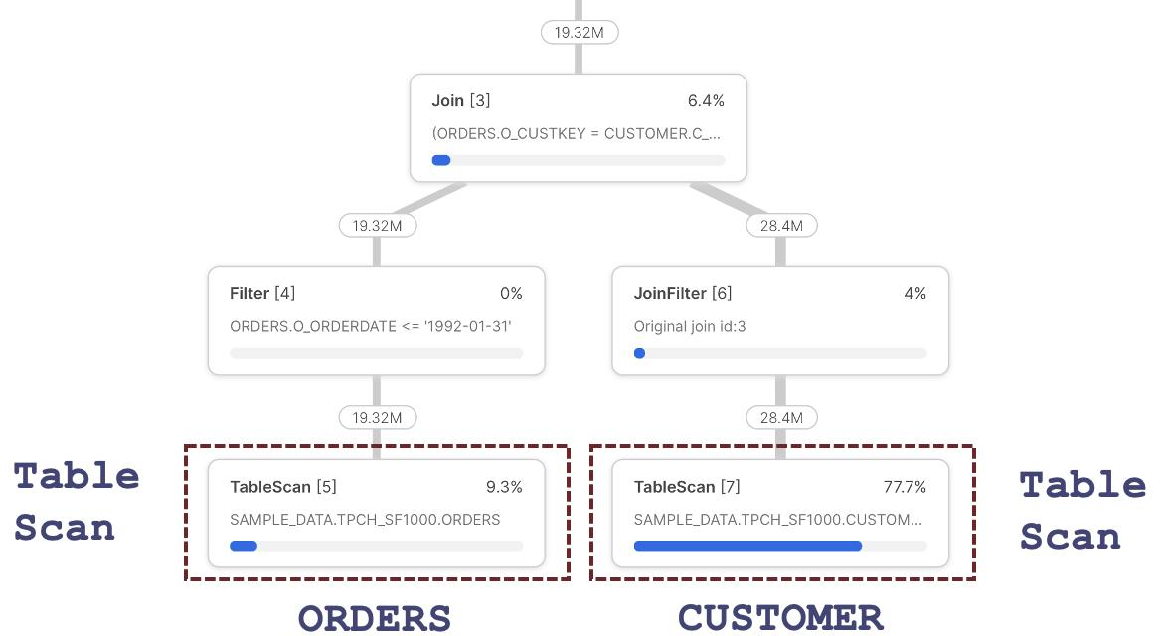
I would examine:
- Table scans.
- Join operations.
- Aggregation.
- Sorting.
- Data spilling.
- Remote disk I/O.
- Local disk I/O.
- Network transfer.
Step 3: Check Data Volume Growth
Perhaps the table previously contained 10 million records but now contains 500 million records.
The same SQL might therefore require significantly more processing.
Step 4: Check Micro-partition Pruning
I would compare partitions scanned against total partitions.
For example:
Metric | Previous | Current
Total partitions | 1,000 | 1,000
Partitions scanned | 50 | 900
Execution time | 2 min | 20 min
This could indicate poor pruning or changes in data distribution.
Step 5: Check Warehouse Size
Perhaps the warehouse was changed from Large to X-Small.
I would verify the warehouse configuration.
Step 6: Check Concurrent Workloads
Other queries may be consuming warehouse resources and creating queueing.
Step 7: Check Data Spilling
If a query requires more memory than available, Snowflake may spill intermediate data to local or remote storage.
This can significantly increase execution time.
Step 8: Check Cache
The previous execution may have benefited from persisted result reuse or warehouse cache.
The current execution may not.
Possible root causes:
- Data volume increased.
- Micro-partition pruning became less effective.
- Warehouse size was reduced.
- Increased concurrent workloads.
- Query spilling.
- Data skew or changed data distribution.
- Changes in underlying table structure or statistics.
- Cache reuse is no longer available.
Interview conclusion:
I would compare the Query Profile, Query History, warehouse configuration, and data volume before changing the SQL.
Q21. Your Snowflake warehouse is consuming more credits than expected. How would you identify the root cause?
Answer:
I would investigate warehouse credit consumption, query execution patterns, idle time, warehouse sizing, and concurrency.
Step 1: Check Warehouse Credit Consumption
I would use the WAREHOUSE_METERING_HISTORY view.
SELECT
WAREHOUSE_NAME,
SUM(CREDITS_USED) AS TOTAL_CREDITS
FROM SNOWFLAKE.ACCOUNT_USAGE.WAREHOUSE_METERING_HISTORY
WHERE START_TIME >= DATEADD(DAY, -7, CURRENT_TIMESTAMP())
GROUP BY WAREHOUSE_NAME
ORDER BY TOTAL_CREDITS DESC;
This identifies which warehouses are consuming the most credits.
Step 2: Check Warehouse Running Time
I would check:
- Warehouse size.
- Auto-suspend configuration.
- Idle time.
- Auto-resume activity.
- Number of clusters.
A warehouse running continuously without meaningful workloads can increase costs.
Step 3: Identify Expensive Queries
SELECT
QUERY_ID,
WAREHOUSE_NAME,
QUERY_TYPE,
TOTAL_ELAPSED_TIME,
BYTES_SCANNED,
EXECUTION_STATUS
FROM SNOWFLAKE.ACCOUNT_USAGE.QUERY_HISTORY
WHERE START_TIME >= DATEADD(DAY, -7, CURRENT_TIMESTAMP())
ORDER BY TOTAL_ELAPSED_TIME DESC
LIMIT 20;
I would identify:
- Long-running queries.
- Repeated queries.
- Queries scanning large volumes of data.
- Queries with unnecessary processing.
Step 4: Check Warehouse Load
I would investigate whether the warehouse is oversized or underutilized.
Step 5: Check Multi-cluster Configuration
If the warehouse has multiple clusters, I would verify whether the minimum cluster count is unnecessarily high.
Step 6: Implement Cost Optimization
Possible improvements:
Problem | Solution
Warehouse running idle | Configure AUTO_SUSPEND
Oversized warehouse | Reduce warehouse size after testing
High concurrency | Optimize multi-cluster settings
Repeated expensive queries | Optimize SQL and reuse results where possible
Large data scans | Improve filtering and pruning
ETL and BI contention | Separate workloads
Unnecessary task execution | Review task scheduling
Step 7: Implement Resource Monitors
I would configure resource monitors to track and control warehouse credit consumption.
Example:
CREATE OR REPLACE RESOURCE MONITOR RM_BI
WITH CREDIT_QUOTA = 500
FREQUENCY = MONTHLY
TRIGGERS
ON 75 PERCENT DO NOTIFY
ON 90 PERCENT DO NOTIFY
ON 100 PERCENT DO SUSPEND;
Resource monitors can help control credit usage for assigned warehouses. They do not cover every type of Snowflake consumption, so account-level billing should also be reviewed.
Interview conclusion:
I would identify the warehouse responsible for excessive consumption, investigate its query and usage patterns, and then optimize warehouse sizing, auto-suspend, concurrency, and SQL performance.
Q22. A dbt incremental model is generating duplicate records even though "unique_key" is configured. How would you investigate?
Answer:
I would investigate the model configuration, unique-key quality, incremental filter logic, merge strategy, and source data.
An important point is that configuring unique_key does not automatically guarantee that the target table will contain unique records.
Step 1: Check the dbt Model Configuration
Example:
{{
config(
materialized='incremental',
unique_key='CUSTOMER_ID',
incremental_strategy='merge'
)
}}
I would verify:
- Is the model materialized as incremental?
- Is the unique key correct?
- Is the merge strategy being used?
- Is the incremental filter correct?
Step 2: Check Duplicate Records in the Source
SELECT
CUSTOMER_ID,
COUNT(*) AS RECORD_COUNT
FROM SOURCE_CUSTOMERS
GROUP BY CUSTOMER_ID
HAVING COUNT(*) > 1;
If the source contains multiple records for the same customer, the merge may encounter multiple source matches.
Step 3: Check Duplicate Records in the Target
SELECT
CUSTOMER_ID,
COUNT(*) AS RECORD_COUNT
FROM CUSTOMER_TARGET
GROUP BY CUSTOMER_ID
HAVING COUNT(*) > 1;
This helps determine whether duplicates already exist in the target table.
Step 4: Check NULL Values
SELECT *
FROM SOURCE_CUSTOMERS
WHERE CUSTOMER_ID IS NULL;
NULL values in unique-key columns can cause matching problems because NULL does not compare equal to NULL using ordinary equality.
Step 5: Check Composite Unique Keys
Sometimes a single column is not sufficient to identify a record.
For example:
CUSTOMER_ID | ORDER_ID
101 | 5001
101 | 5002
In this case, CUSTOMER_ID is not unique.
The correct unique key may be:
unique_key=['CUSTOMER_ID', 'ORDER_ID']
Step 6: Check Incremental Filter Logic
Example:
{% if is_incremental() %}
WHERE UPDATED_AT >= (
SELECT MAX(UPDATED_AT)
FROM {{ this }}
)
{% endif %}
I would check:
- Are late-arriving records being handled?
- Are records with identical timestamps missed or repeatedly selected?
- Is the timestamp reliable?
- Are source updates being captured correctly?
Step 7: Deduplicate Source Records
If the source contains multiple records for the same key, I would select the latest record before the merge.
SELECT *
FROM SOURCE_CUSTOMERS
QUALIFY ROW_NUMBER() OVER (
PARTITION BY CUSTOMER_ID
ORDER BY UPDATED_AT DESC
) = 1;
This keeps one latest record per customer, assuming UPDATED_AT provides a reliable ordering.
Step 8: Review the dbt Logs and Generated SQL
I would review:
- dbt logs.
- Compiled SQL.
- Generated MERGE statement.
- Model execution history.
- Incremental strategy.
Step 9: Repair Existing Duplicates
If duplicates already exist in the target, I would develop a controlled deduplication and reconciliation process.
After validation, I would consider a full refresh if appropriate.
Important interview point:
The unique_key tells dbt how to match incoming records against existing records. It is not a database-enforced unique constraint.
Also, both the incoming dataset and existing target should have the expected unique grain. dbt documentation specifically highlights duplicate and NULL unique-key values as potential causes of incremental model issues.
dbt Developer Hub+2
Q23. A Snowflake Task is executing successfully, but the target table is not getting updated. How would you debug it?
Answer:
I would investigate the task execution history, SQL logic, task dependencies, source data, permissions, and transaction behavior.
A task showing a successful execution does not necessarily mean that rows were inserted or updated.
For example, a task may execute successfully but return zero rows because the source query has no matching records.
Step 1: Check Task Status
SHOW TASKS;
Check:
- Task name.
- State.
- Warehouse.
- Schedule.
- Database and schema.
- Error information.
Step 2: Check Task Execution History
SELECT
NAME,
STATE,
SCHEDULED_TIME,
COMPLETED_TIME,
ERROR_CODE,
ERROR_MESSAGE,
QUERY_ID
FROM TABLE(
INFORMATION_SCHEMA.TASK_HISTORY(
SCHEDULED_TIME_RANGE_START =>
DATEADD(HOUR, -24, CURRENT_TIMESTAMP())
)
)
ORDER BY SCHEDULED_TIME DESC;
I would verify whether the task:
- Actually executed.
- Completed successfully.
- Executed the expected SQL statement.
- Returned an error.
- Was skipped or had a dependency issue.
Step 3: Execute the SQL Manually
I would take the SQL statement from the task and execute it manually.
Example:
INSERT INTO TARGET_CUSTOMERS
SELECT *
FROM SOURCE_CUSTOMERS
WHERE UPDATED_AT >= CURRENT_DATE();
Then I would verify whether the source query returns any records.
SELECT COUNT(*)
FROM SOURCE_CUSTOMERS
WHERE UPDATED_AT >= CURRENT_DATE();
If the count is zero, the task may be successful but there is no data to insert.
Step 4: Check Database and Schema Context
Sometimes the task may be inserting into a different database or schema than expected.
I would verify:
SELECT CURRENT_DATABASE(), CURRENT_SCHEMA();
I would also check the fully qualified target table name.
Step 5: Check Task Permissions
I would verify whether the task owner role has the necessary privileges.
For example:
- USAGE on the database.
- USAGE on the schema.
- SELECT on the source table.
- INSERT or UPDATE on the target table.
- USAGE on the warehouse, if using a user-managed warehouse.
Step 6: Check Task Dependencies
If the task is part of a task graph, I would verify that predecessor tasks have completed successfully and that the expected execution path was followed.
Step 7: Check Stream Data (If Used)
If the task processes data from a Snowflake Stream, I would check whether the stream contains unconsumed change records.
Example:
SELECT *
FROM CUSTOMER_STREAM;
Also check:
SHOW STREAMS;
I would verify:
- Whether the stream contains records.
- Whether another process has consumed the stream.
- Whether the stream is stale.
- Whether the task's WHEN condition is evaluating as expected.
Step 8: Check Stored Procedure Logic
If the task calls a stored procedure, I would inspect the procedure for:
- Incorrect table references.
- Conditional logic.
- Exception handling.
- Transaction rollback.
- Incorrect dynamic SQL.
- Missing COMMIT statements where explicit transaction management is used.
Step 9: Validate the Target Table
SELECT COUNT(*)
FROM TARGET_CUSTOMERS;
I would also check the latest update timestamp:
SELECT MAX(UPDATED_AT)
FROM TARGET_CUSTOMERS;
This helps establish whether the table has received new data.
Step 10: Check Query History Using QUERY_ID
Once I obtain the QUERY_ID from task history, I would use it to inspect the actual SQL execution.
SELECT
QUERY_ID,
QUERY_TEXT,
EXECUTION_STATUS,
ROWS_INSERTED,
ROWS_UPDATED,
ROWS_DELETED
FROM SNOWFLAKE.ACCOUNT_USAGE.QUERY_HISTORY
WHERE QUERY_ID = '<QUERY_ID>';
This can help determine whether the statement actually inserted or updated any rows.
Possible root causes:
Root cause | Troubleshooting action
Source query returns zero rows | Validate WHERE conditions
Wrong target table | Verify database and schema
Missing permissions | Check task owner privileges
Stream is empty | Check stream consumption
Task dependency issue | Review task graph
Stored procedure logic issue | Debug procedure
Transaction rollback | Review transaction handling
Incorrect date filter | Validate timestamps and time zones
Task condition not met | Check WHEN condition
Interview conclusion:
I would not assume that a successful task execution means successful data loading. I would trace the execution from task history to the actual query, validate the source data, inspect the SQL logic, and finally verify the target table.
7. Quick Revision – Important Snowflake Interview Concepts
This table will help you revise all 23 questions before an interview.
Concept | Key point to remember
Micro-partition | Automatic columnar storage units
Column pruning | Reads only required columns
Partition pruning | Skips irrelevant micro-partitions
Virtual warehouse | Provides compute resources
Scale up | Increases compute capacity
Multi-cluster | Handles concurrent queries
ETL | Transform before loading
ELT | Load first, transform inside Snowflake
Dynamic masking | Controls visibility of sensitive data
Result cache | Reuses previous query results
Warehouse cache | Stores previously accessed data locally
Metadata | Helps optimize query execution
Warehouse suspension | Clears local warehouse cache
Separate warehouses | Isolate workloads
Query Profile | Identifies query performance bottlenecks
Resource Monitor | Helps control warehouse credit usage
dbt unique_key | Identifies matching records
dbt incremental | Processes new or changed records
Snowflake Task | Automates SQL execution
Snowflake Stream | Tracks data changes
Task History | Monitors task execution
8. Important SQL Commands for Practical Interviews
These are useful commands to practise in a Snowflake environment.
Requirement | SQL / command
Check warehouses | SHOW WAREHOUSES;
Check tasks | SHOW TASKS;
Check streams | SHOW STREAMS;
Check tables | SHOW TABLES;
Query history | SNOWFLAKE.ACCOUNT_USAGE.QUERY_HISTORY
Warehouse credits | SNOWFLAKE.ACCOUNT_USAGE.WAREHOUSE_METERING_HISTORY
Task execution | INFORMATION_SCHEMA.TASK_HISTORY()
Check current warehouse | SELECT CURRENT_WAREHOUSE();
Check current role | SELECT CURRENT_ROLE();
Check current database | SELECT CURRENT_DATABASE();
Check current schema | SELECT CURRENT_SCHEMA();
9. My Recommended Preparation Priority
For Snowflake Data Engineer / Snowflake DBA interviews, I recommend prioritizing these topics:
High priority
Master first
- Micro-partitioning and pruning
- Virtual warehouse sizing
- Query Profile and performance troubleshooting
- ETL vs ELT
- Result Cache vs Warehouse Cache
- Warehouse credit optimization
Medium priority
Practise next
- Multi-cluster warehouses
- Workload isolation
- dbt incremental models
- Dynamic data masking
- Snowflake Tasks and Streams
Advanced priority
Deep dive
- Query spilling and execution plans
- Resource monitors and cost management
- Task graphs and stored procedures
- Incremental MERGE troubleshooting
10. Official Learning Resources
These are useful references for hands-on preparation:
- Snowflake – Virtual Warehouse Considerations
- Snowflake – Persisted Query Results
- Snowflake – Optimizing Warehouse Cache
- dbt – Incremental Models
- Snowflake – dbt Best Practices
My final recommendation: Don't just memorize these answers. Practise creating warehouses, loading sample tables, executing queries, checking Query Profile, creating Tasks, and building dbt incremental models. Being able to explain what you personally investigated and how you resolved a production issue will make your interview answers much stronger.
I can also help you prepare a 30-question advanced Snowflake interview set with real-time production scenarios, SQL exercises, and detailed answers as your next preparation step.

